

1st West Craven Scouts Fundraising Pack

Skills for Life Through Adventure

Welcome

Dear Supporters,
On behalf of everyone at 1st West Craven Scouts, thank you for your interest in helping us raise vital funds. Your support enables us to provide young people with life-changing adventures, essential equipment, and unforgettable experiences. Every pound you raise goes directly towards helping our Scouts develop Skills for Life through outdoor challenges, community service, and teamwork.

Our Scout group runs a busy programme of activities, from hiking and camping to climbing, orienteering, and cooking. Your fundraising will help purchase new tents, maintain our building, subsidise trips for families who need extra support, and ensure every young person has the opportunity to take part.

Please use the templates and ideas in this pack to start planning your event. We are here to support you at every step. If you have any questions, get in touch with our Team at scouts@westcravenscouts.org.uk

Thank you once again for your generosity and dedication. Together, we can give our Scouts the adventure of a lifetime.

Yours sincerely,
Steven Underwood
Chair of Trustees, 1st West Craven Scouts

Getting Started Guide

Step 1: Choose Your Fundraising Idea
Browse the ideas section of this pack. Pick something you enjoy - baking, walking, or hosting an event - and that fits your available time and resources.

Step 2: Plan Your Event
Use the Event Planning Checklist to organise details: date, venue, supplies, volunteers, and safety. Let the Scout Leader know your plans at least 2 weeks before your event.

Step 3: Promote Your Fundraiser
Use our ready-made templates for social media, WhatsApp, and posters. Share with friends, family, and local community groups. The more people know, the more you raise.

Step 4: Run Your Event
Follow safety and money-handling guidelines. Have fun and make sure everyone involved feels welcome and appreciated.

Step 5: Submit Your Funds
Pay in all money collected within 7 days. Use the dedicated Scout bank account or hand cash to the Treasurer in a sealed, labelled envelope.

Step 6: Celebrate & Share
Send photos and a short story about your event to the Scout newsletter. Your success inspires others to get involved!

Fundraising Ideas Section

Easy Ideas
- Sponsored silence or readathon
- Bake sale at school or church
- Car washing service
- Gift-wrapping station at local shops (December)
- Guess the number of sweets in a jar

Community Events
- Fetes & Fairs with stalls, games, and BBQ
- Quiz night at the village hall
- Film night — show a family movie
- Pancake breakfast or soup lunch
- Christmas craft fair and carol singing

Active Challenges
- Sponsored walk — e.g., Pendle Hill, the Yorkshire Three Peaks
- Mountain bike ride on a local trail
- Swimathon — swim a set number of lengths
- Abseil or climbing challenge

Creative Ideas
- Calendar featuring photos of local area
- Homemade craft sale — badges, keyrings, candles, tote bags
- Photography competition with entry fee
- Auction of donated goods or services

Event Planning Checklist

Category | Category | Comment
Venue | Book space (Scout HQ, church hall, school, village hall)
Venue | Check insurance and risk assessment requirements
Venue | Arrange toilets, electricity, heating, and parking
Promotion | Create event on Facebook and local community pages
Promotion | Print A4 posters and display in shop windows, library, school
Promotion | Send WhatsApp blasts using our template
Supplies | Buy food, drink, ingredients, raffle prizes, decorations
Supplies | Prepare gazebos, tables, chairs, tablecloths, signs
Supplies | Bring change float for cash sales
Volunteers | Recruit helpers
Volunteers | Assign roles: cashier, ticket seller, activity lead, cleaner
Volunteers | Brief team on safety, fire exits, and money handling
Safety | Complete event risk assessment — if needed
Safety | First aid kit on site
Safety | Check food hygiene rules if selling homemade items

Promotion Templates

Social Media Post

[Insert your event name and date]
Join us and support 1st West Craven Scouts! We are raising funds for camps, equipment, and adventures for local young people.
Date: [Date]
Time: [Start time] — [End time]
Location: [Venue address]
Entry: [Free / Ex per person / suggested donation]
Come along for: [list highlights — e.g., games, raffle, cakes, face painting]
Every penny raised stays with 1st West Craven Scouts. Tag your friends and share!
#SkillsForLife #WestCravenScouts #Fundraising #AdventureAwaits

WhatsApp Message

Hi everyone! I am fundraising for 1st West Craven Scouts to help them buy camping gear and fund trips. I'm running [event name] on [date] at [time] at [location]. It would mean the world to me if you could come along, take part, or donate. Even sharing this message helps. Thank you!

Sponsor Request Letter

[Your Name] [Your Address] [Date]

[Business Name]

[Business Address]

Dear [Contact Name / Sir or Madam],
I am writing on behalf of 1st West Craven Scouts — a local Scout group providing life-changing adventure, skills, and opportunities for young people in our community. We are currently running a fundraising campaign to support their programme of camps, equipment, and activities.

We would be so grateful if [Business Name] could support our efforts by [sponsoring our event / donating a prize for our raffle / contributing towards our minibus fund]. In return, we would be delighted to feature your logo on our promotional materials, thank you on our social media channels, and mention your support at our Scout meetings.

Your support, whether large or small, will directly help local young people build confidence, teamwork, and resilience. Please contact me on [phone number] or [email] to let me know how you can help.

Thank you for considering this request.

Yours sincerely,
[Your Name]
Fundraising Volunteer, 1st West Craven Scouts

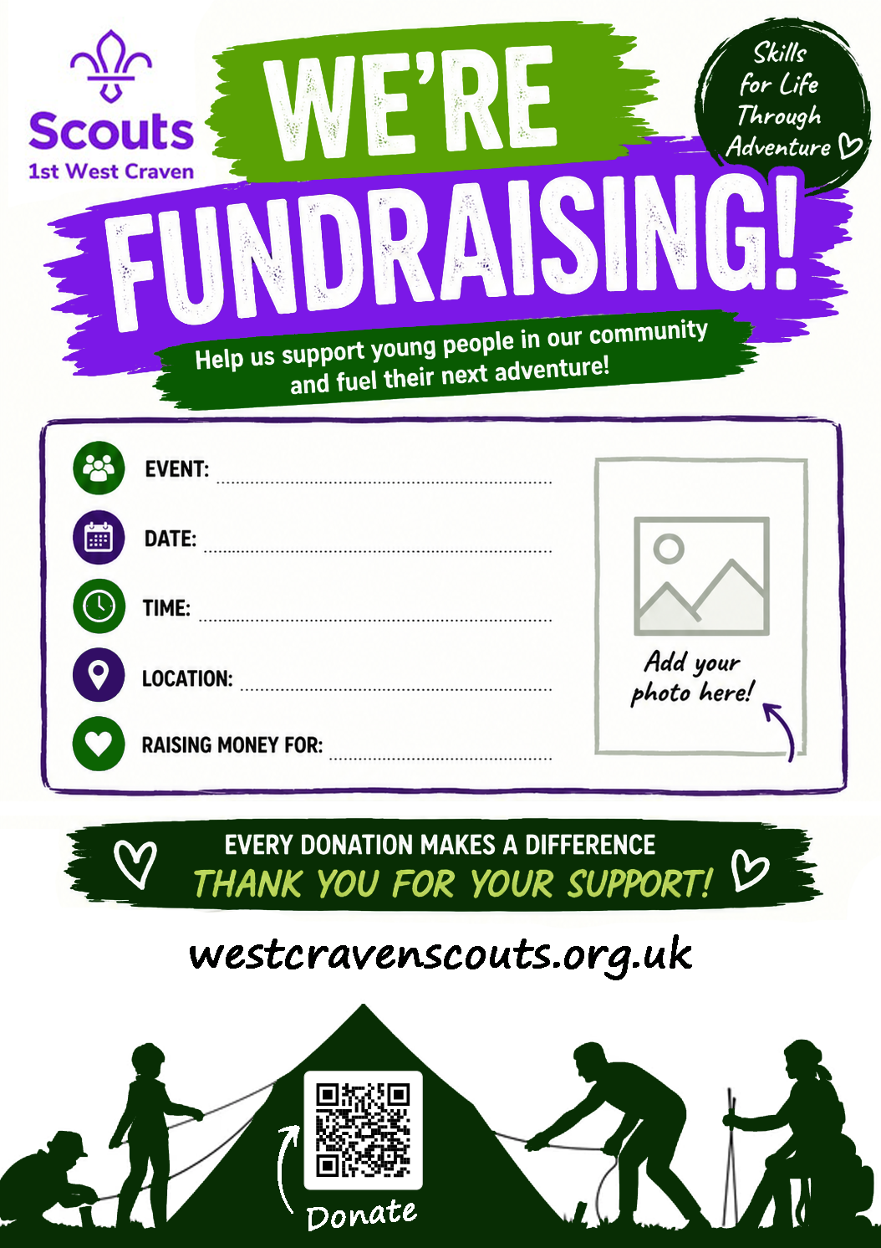

Money Handling & Safety Guide

Cash Handling
- Always have two adults present when counting or handling money.
- Use a locked cash box. Keep it out of public view whenever possible.
- Count money as soon as possible after the event, ideally within the same room.
- Pay cash into the Scout bank account within 7 days. Contact the Treasurer for account details.
- Never leave cash unattended in a vehicle or at a venue overnight.

Bank Transfers
- If donors prefer to give online, direct them to the Scout group's bank account. Share details via your event page or WhatsApp.
- Ask donors to use the reference: Fundraiser_[Your Name] so we can track donations.
- Do not share bank details publicly on social media - direct message or secure email only.

Supervision & Safeguarding
- All events must follow Scout safeguarding policies. At least one DBS-checked adult must always be present.
- Young people under 18 must not handle cash without adult supervision.
- Report any concerns to a Scout Leader immediately.

Impact Section

How Your Fundraising Makes a Difference
Every pound you raise goes directly to the young people of 1st West Craven Scouts. Your support helps us:
- Purchase new camping tents, stoves, and outdoor gear for expeditions
- Maintain our building so we can continue it use
- Subsidise camp fees for families facing financial difficulty — ensuring no one is left behind
- Buy activity resources for weekly meetings
Through scouting, young people gain confidence, leadership skills, resilience, and a love for the outdoors. Your fundraising directly creates these Skills for Life. From a Scout's first campfire to their Duke of Edinburgh expedition, your support is at the heart of their journey.

Thank You

Thank you for taking the time to read this pack and for considering — or already doing — a fundraiser for 1st West Craven Scouts. Your efforts, enthusiasm, and generosity make a real, lasting difference to the lives of young people in our community.

Whether you hold a bake sale, climb a mountain, run a quiz night, or ask a local business for help - every single act of kindness adds up. You are part of a team that helps young people grow, explore, and become the best they can be.

We would love to hear your story. Please share your photos and fundraising journey with us at scouts@westcravenscouts.org.uk or tag us on social media.

From all of us at 1st West Craven Scouts: thank you.
You are helping to build the next generation of adventurers and leaders.
Skills for Life. Adventure for all.

